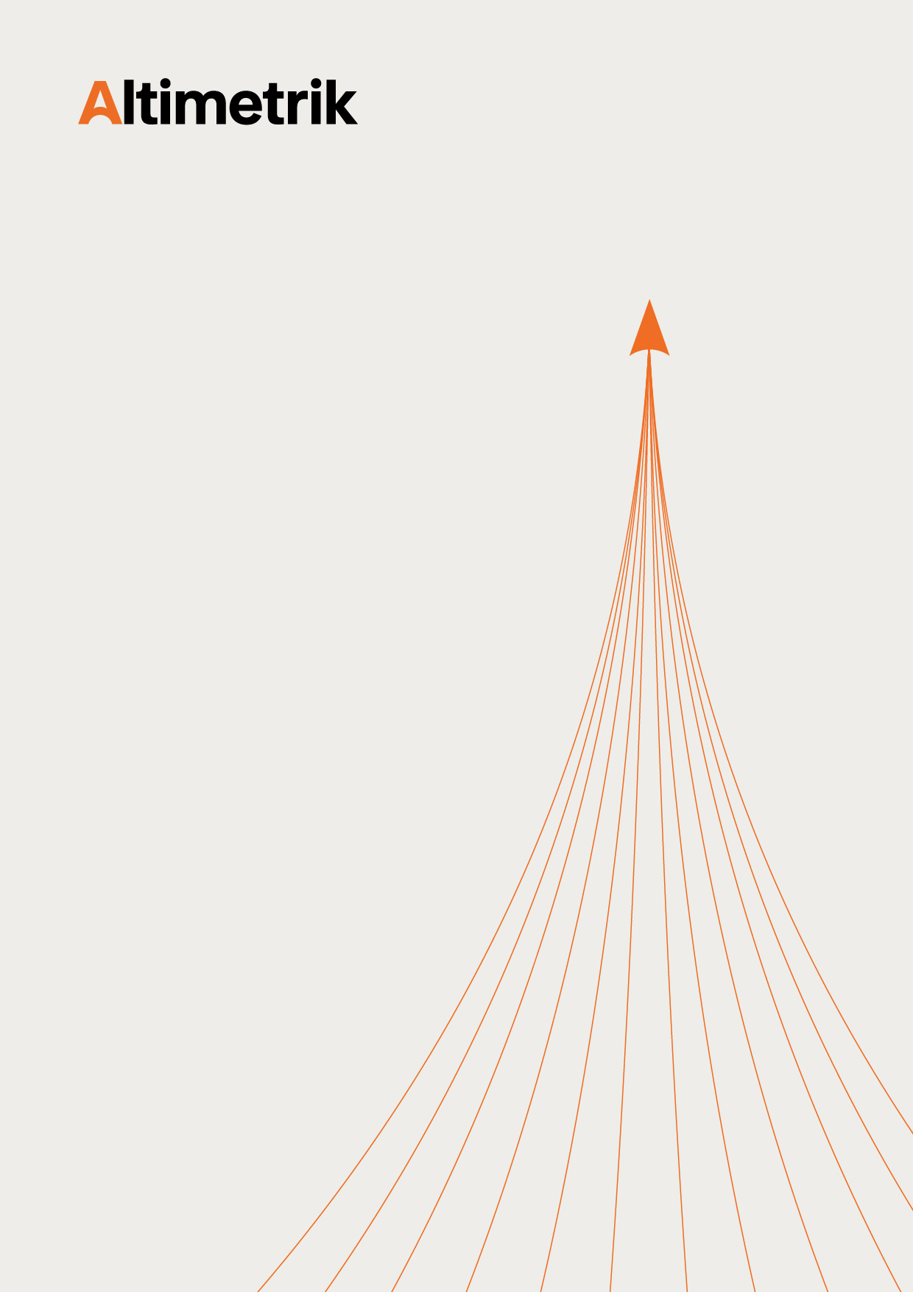

Storage Media Management Policy v2.0
Document Summary:

Policy ID | ESGC-IS-33
Revision Number | 2.0
Effective Date | 1-July-2026
Owner | ESGC
Approved By | Raghavendra K (CISO)
Document Status | Approved
Document Label | Internal Information

This document contains internal and proprietary information of Altimetrik and is intended for authorized internal use only. The information contained herein shall not be disclosed, reproduced, distributed, or shared with any third party without prior written consent from Altimetrik. Unauthorized access, use, modification, disclosure, or distribution of this document is strictly prohibited and may result in disciplinary and/or legal action. Altimetrik reserves the right to modify or update this document as required. The version published on the official Altimetrik intranet portal shall be considered the latest approved version for reference.

Revision History:

Date of Revision | Version | Description | Author | Reviewed by | Approved by | Approved Date
2-Jun-2026 | 2.0 | Policy harmonized and revised to establish a unified standard across Altimetrik group companies | Sunanda K (Senior Engineer, ESGC) | - Shivaramakrishna Seetharaman (Head-IT infra)  - Doss Sridevi Saravanan (Manger-IT infra)  - Jagadeesh Hegde (Group Manager - IT infra)  - Jagadish PG  (Senior Manager, ESGC) | Raghavendra K (CISO) | 26-Jun-2026

TABLE OF CONTENTS

1. INTRODUCTION 3
2. ISO/IEC 27001 CONTROL REFERENCE 4
3. SCOPE 4
4. ACRONYMS USED 4
5. POLICY 4
5.1 Removal Storage Media 4
5.2 Storage Media Handling 5
5.3 Physical Storage Media Transfer/Removal 5
5.4 Storage Media Disposal 6
7. KEY PERFORMANCE INDICATOR 7
8. DOCUMENTS REFERENCES 7

Introduction

The purpose of this policy is to define security controls to manage storage media, including removable media, through their life cycle of acquisition, use, transportation, and disposal as per the organization information security requirements.

ISO/IEC 27001 control reference

- A.5.1 – Information Transfer
- A.7.10 – Storage Media

Scope :
- This policy applies to Altimetrik Group Companies (hereafter referred to as the organization).
- All types of storage media including removable media, internal and external storage media. (Media including but not limited to paper, physical files, hard drives, portable storage devices, compact and DVDs, backup tapes, etc.) owned by organization across all global locations and facilities.
- All employees, contractors and service providers working for the Organisation, and using its information and information systems.
In case of any conflict, applicable laws & regulations shall always supersede this policy.

Acronyms used

Acronym | Expanded Form
CISO | Chief Information Security Officer
ESGC | Enterprise Security Governance and Compliance is an Enterprise Information Security Department
IT Infra | Information Technology and Infrastructure Operations
USB | Universal Serial Bus
CD | Compact Disc
DVD | Digital Video Disc or Digital Versatile Disc

Policy

Removal Storage Media
- The usage of removable or external data storage media such as USB memory sticks, CD, DVD, tape drives, external hard disk drives etc. shall be prohibited by default. Only authorized department or user shall use removable media for information backup purpose (if online backup facility not there).
- Users shall be allowed to use only Organisation owned removable storage devices. Removable storage devices shall be provided only for business purposes for the valid business need.
- USB access requests shall be centrally processed as exceptions and shall be approved by the CISO in consultation with the COO for the business need. Additionally, a specific agreement regarding USB usage must be signed for such exceptions.
- Port for connecting external storage media (USB memory sticks, external hard disk drives etc.) to Organisation systems (servers and end user systems) shall be disabled by default.
- Copying of information to removable storage media devices shall be monitored using automated tools by IT Infra Department.
- Removable storage media storing confidential and sensitive information shall be encrypted to safeguard the Organisation information from unauthorized access.
- Storage media prone to degrade or with a limited lifespan shall be tracked for their usage suitability. Information shall be transferred to new storage media before the old storage media becomes unusable.
- IT Infra department shall maintain records of all user endpoints that have enabled storage media ports, including the inventory of removable storage devices.
- Malware protection software shall be configured to scan the removable media for potential malware or restricted file formats prior to use in Organisation systems.
- Usage of external storage media in Organisation systems shall be logged and monitored.

Storage Media Handling
- All storage media including paper documents storing Organisation information shall be classified and labelled as per organisation information classification schemes.
- All storage media including paper documents shall be stored in a safe, secure environment according to their information classification, safeguarding them from environmental threats like heat, moisture, humidity, electronic field, or ageing, in strict accordance with manufacturers’ specifications or industry best practices.
- External storage media shall be physically stored in a secure place to protect them against loss and unauthorized access. Only authorized individuals shall have access to media.
- Organisation information stored on an external storage media shall remain the property of the Organisation and shall reserve the right to recover information held on any external storage device.
- Information owner shall review the contents of the external storage media on a regular basis to identify out-of-date and unwanted information and remove them securely.
- Enterprise Information Security Department will conduct quarterly reviews of external storage media, including USB drives and external hard disks.

Physical Storage Media Transfer/Removal
- Storage media storing Organisation information shall be transferred/ removed only for business purposes and shall be approved by the IT Infra Department. For paper documents approval of respective department head shall be taken.
- Department head shall be responsible to ensure and verify receiver’s correct address and secure transport arrangements.
- Storage media containing confidential and sensitive information shall require Enterprise Information Security Department approval.
- Records of all physical storage media including paper documents transfer shall be maintained for audit purpose. Details captured include but not limited to:
- Content and classification of the media
- Sender details
- Approver details
- Date and time of transfer
- Destination details
- Recipient details
- Transit custodian details
- Adequate packaging of media shall be done to protect the contents from any physical damage, unauthorized access, misuse, tempering, corruption of data during transportation of media.
- Storage media shall be transferred only through approved transport and courier service providers when transfer of storage media is done through external party.
- Internal storage media (System Hard Disk) with equipment shall not be permitted to send outside of the Organisation.

Storage Media Disposal
- IT Infra department shall securely delete data or format the storage media to be reused within the Organisation prior issuing it to another user or using for another project.
- Storage Media (including paper documents, hard drives in printers, scanners, fax machines, desktops and servers, tapes, flash drives, CD/DVD, mobile devices, removable storage devices) containing Organisation ‘Sensitive & Confidential’ information shall be disposed securely when no longer required. Information owners (IT Infra for electronic media and F&A for paper documents) and Enterprise Information Security Department approval shall be required for disposal of storage media.
- Storage media identified to be disposed shall be done only by authorized individuals and non-retrievable methods shall be applied for secure disposal of storage media.
- In-case external vendor is contracted for disposal, only approved (PCB Certified) vendor meeting the Organisation security requirements shall be allowed for media disposal services.
- Secure disposal methods for electronic storage media shall include:
- Basic formatting / Physically destroying/ shredding the media making it undetectable/ unreadable by any person/device.
- Use of degausser to reduce the magnetic flux of the media to virtually zero.
- Secure disposal methods for paper documents include:
- Level I documents (Sensitive classified) are those that contain information that is of the highest security and confidentiality and those that include any personal data. These documents shall be disposed of as confidential waste (cross-cut shredded and incinerated).
- Level II documents (Confidential classified) are proprietary documents that contain confidential information. The documents should be cross-cut shredded and then placed into locked rubbish bins for collection by an approved disposal firm.
- Level III documents (Internal and public classified) are those that do not contain any confidential information or personal data. These should be either strip-shredded or disposed of via a recycling company.
- Disposal records for storage media containing confidential and sensitive information shall be maintained.

Key performance indicator

Srl. | KPI Definition | Frequency
1 | Number of end points active with removable media ports without authorization | Half Yearly
2 | Number of Security incidents regarding loss of storage media | Half Yearly
3 | Number of Storage media containing sensitive or confidential information disposal without authorization | Half Yearly

Documents references

Srl. | Document Name
1. | Backup and Recovery Policy
2. | Information Classification and Handling Policy
3. | Procedure for Exception Handling and Risk Acceptance

